LOGISTICS DATA ANALYST
INTERNSHIP PROJECT
PROJECT REPORT
Advanced Data Analysis and
Visualization in Logistics

Prepared by | Japkirat Kaur
Role | Logistics Data Analyst Intern
Organization | Yuva Intern
Reporting period | September 2026

Hypothetical dataset | Python-based exploratory analysis | 1,500 simulated shipments

1. Executive Summary
This report presents an advanced exploratory analysis of a hypothetical shipment-level logistics dataset containing 1,500 simulated records and 13 variables. The project evaluates delivery time, transportation cost, shipment volume, warehouse processing, operational delay, transport mode, regional performance, monthly workload, and customer ratings. The analysis uses Python-based descriptive statistics, KPI measurement, grouped comparisons, Pearson correlation, and multiple visualization types to translate simulated logistics data into structured decision-support insights.
Headline result
Under the project-specific rule that a shipment is on time when simulated delay is 5 hours or less, 1,036 of 1,500 shipments are on time (69.07%), while 464 (30.93%) are delayed.

The strongest operational patterns include a moderate positive relationship between shipment distance and transportation cost (r = 0.600), a stronger positive relationship between distance and delivery time (r = 0.679), a weak relationship between warehouse processing and delay (r = 0.221), and a very weak relationship between shipment volume and cost (r = 0.071). The simulated transport modes also demonstrate a clear cost-service trade-off: Air is fastest but most expensive, while Sea is least expensive but slowest.
The delay-to-customer-rating correlation is strongly negative (r = -0.847), but this relationship was deliberately embedded in the simulation design. It is therefore treated as a demonstration of analytical interpretation rather than independent causal evidence. All recommendations in this report are decision-support examples that would require validation with real operational data before implementation.

Key KPI Snapshot
KPI | Result
Total shipments | 1,500
Average delivery time | 30.11 hours
Median delivery time | 26.16 hours
Average transportation cost | 1,346.28
Average delay | 4.44 hours
On-time delivery rate | 69.07%
Average warehouse processing | 3.97 hours
Average customer rating | 4.24 / 5

2. Objective and Scope
The objective of this project is to deepen logistics analytical skills through the simulation, exploration, analysis, visualization, and interpretation of shipment-level data using Python. The work focuses on identifying trends, distributions, cost drivers, operational bottlenecks, delivery-reliability patterns, and performance differences that can support data-driven logistics decisions.

Scope of analysis
- Design and simulate a structured logistics dataset with variables relevant to shipment performance.
- Validate dataset completeness, uniqueness, data types, and analytical usability.
- Measure central tendency, variability, distributions, and core logistics KPIs.
- Evaluate relationships among distance, cost, delivery time, shipment volume, warehouse processing, delay, and customer rating.
- Compare transportation modes and regions using operational performance measures.
- Visualize trends, distributions, relationships, and categorical differences using appropriate chart types.
- Translate measured findings into practical recommendations while clearly stating feasibility and limitations.
The dataset is hypothetical. Accordingly, this report does not claim to measure the performance of an actual logistics organization and does not treat simulated patterns as industry benchmarks.

3. Hypothetical Dataset Design and Simulation
Each row represents one simulated shipment. The dataset covers shipment dates from 1 January 2025 to 31 December 2025 and contains 1,500 records across 13 fields. The simulation intentionally incorporates plausible analytical relationships so that the dataset can support meaningful EDA rather than consisting of fully independent random variables.
Variable | Type | Analytical meaning
Shipment_ID | Identifier | Unique shipment identifier
Shipment_Date | Date | Date the shipment was processed
Region | Categorical | Simulated delivery region
Transport_Mode | Categorical | Road, Rail, Air, or Sea
Distance_km | Numeric | Shipment travel distance in kilometres
Shipment_Volume_kg | Numeric | Shipment weight in kilograms
Priority | Categorical | Standard or Express category
Warehouse_Processing_Hours | Numeric | Warehouse processing duration
Delivery_Time_Hours | Numeric | Total delivery duration
Transportation_Cost | Numeric | Simulated transportation cost
Delay_Hours | Numeric | Simulated delay duration
On_Time_Delivery | Categorical | Project-defined on-time indicator
Customer_Rating | Numeric | Simulated satisfaction rating, 1-5

Simulation rationale
Distance and shipment weight contribute to simulated transportation cost; transport mode influences delivery time and cost; warehouse processing and operational variation contribute to delay; and customer rating was intentionally designed to decline as delay increases. These design choices create interpretable logistics patterns for educational analysis.
Important analytical boundary
The on-time classification uses a project-specific threshold: simulated delay of 5 hours or less is classified as on time. This is not presented as a universal logistics-industry standard.

4. Data Validation and Analytical Readiness
Before analysis, the dataset was checked for shape, missing values, duplicate records, duplicate shipment identifiers, and data types. The validation confirms that the simulated dataset is internally complete and suitable for the planned EDA.
Validation check | Result | Interpretation
Rows | 1,500 | Expected simulation size confirmed
Columns | 13 | All designed variables present
Missing values | 0 | No missing-data treatment required
Duplicate rows | 0 | No duplicate-record removal required
Duplicate Shipment_ID values | 0 | Identifier uniqueness confirmed
Shipment_Date | Datetime-compatible | Supports monthly trend analysis

Because the dataset begins in an analytically clean state, this project focuses on advanced exploration and visualization rather than extensive preprocessing. The absence of missing and duplicate records should not be interpreted as typical of real operational logistics data.

5. Exploratory Data Analysis and Descriptive Statistics
Descriptive statistics establish the baseline distribution and variability of the main quantitative variables. Mean and median are interpreted together because several logistics measures are positively skewed.
Metric | Mean | Median | Std. dev. | Min | Max
Distance (km) | 1497.47 | 1464.50 | 846.69 | 62.00 | 2997.00
Shipment volume (kg) | 286.54 | 225.12 | 219.25 | 19.55 | 1570.71
Warehouse processing (h) | 3.97 | 3.58 | 2.14 | 0.56 | 16.11
Delivery time (h) | 30.11 | 26.16 | 19.41 | 2.93 | 95.39
Transportation cost | 1346.28 | 1144.09 | 887.56 | 100.00 | 4437.94
Delay (h) | 4.44 | 2.76 | 4.46 | 0.00 | 25.93
Customer rating | 4.24 | 4.40 | 0.61 | 1.10 | 5.00

Average delivery time is 30.11 hours compared with a median of 26.16 hours, and average transportation cost is 1,346.28 compared with a median of 1,144.08. In both cases the higher mean indicates that relatively large observations pull the average upward. Average delay is 4.44 hours, but the maximum reaches 25.93 hours, showing that a smaller set of shipments experiences materially longer delays.

6. Distribution Analysis

6.1 Delivery Time Distribution
A histogram is appropriate for delivery time because the variable is continuous and the objective is to inspect frequency, spread, skewness, and the presence of a long tail. Mean and median reference lines make the asymmetry directly visible.
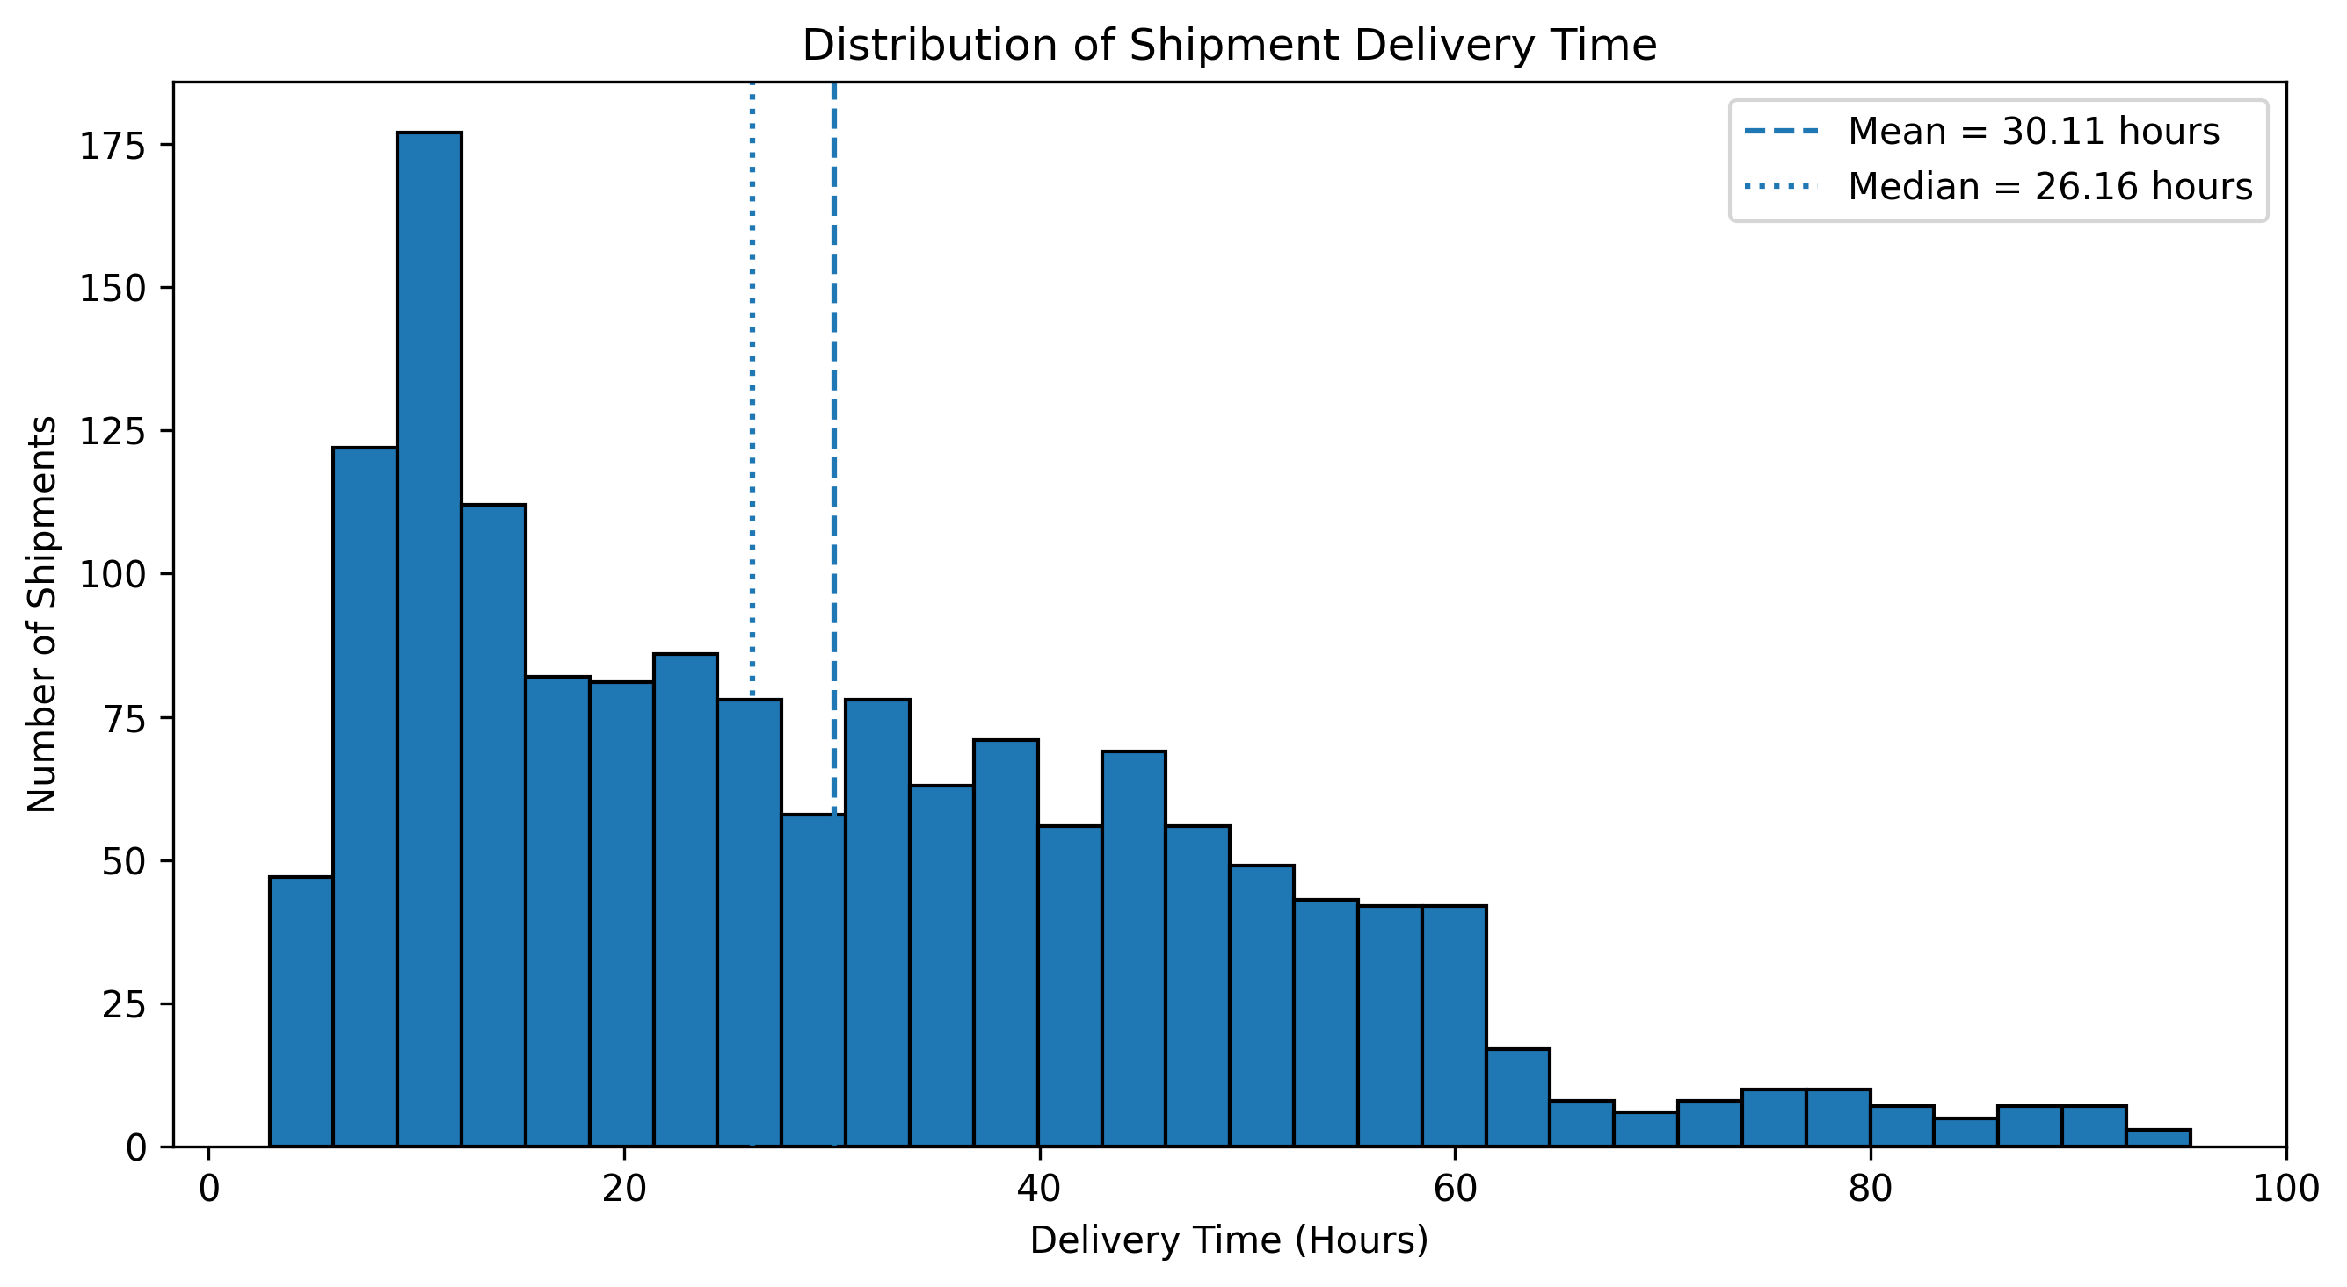
Figure 1. Delivery time distribution with mean and median reference lines.
The distribution is positively skewed. Mean delivery time is 30.11 hours, median delivery time is 26.16 hours, and the maximum reaches 95.39 hours. The right tail identifies long-duration shipments that warrant deeper operational segmentation, but these observations should not automatically be treated as errors because delivery duration also reflects distance and mode.

6.2 Transportation Cost Distribution
A histogram is also suitable for transportation cost because it shows how frequently shipments occur across cost ranges and whether high-cost shipments disproportionately influence the average.
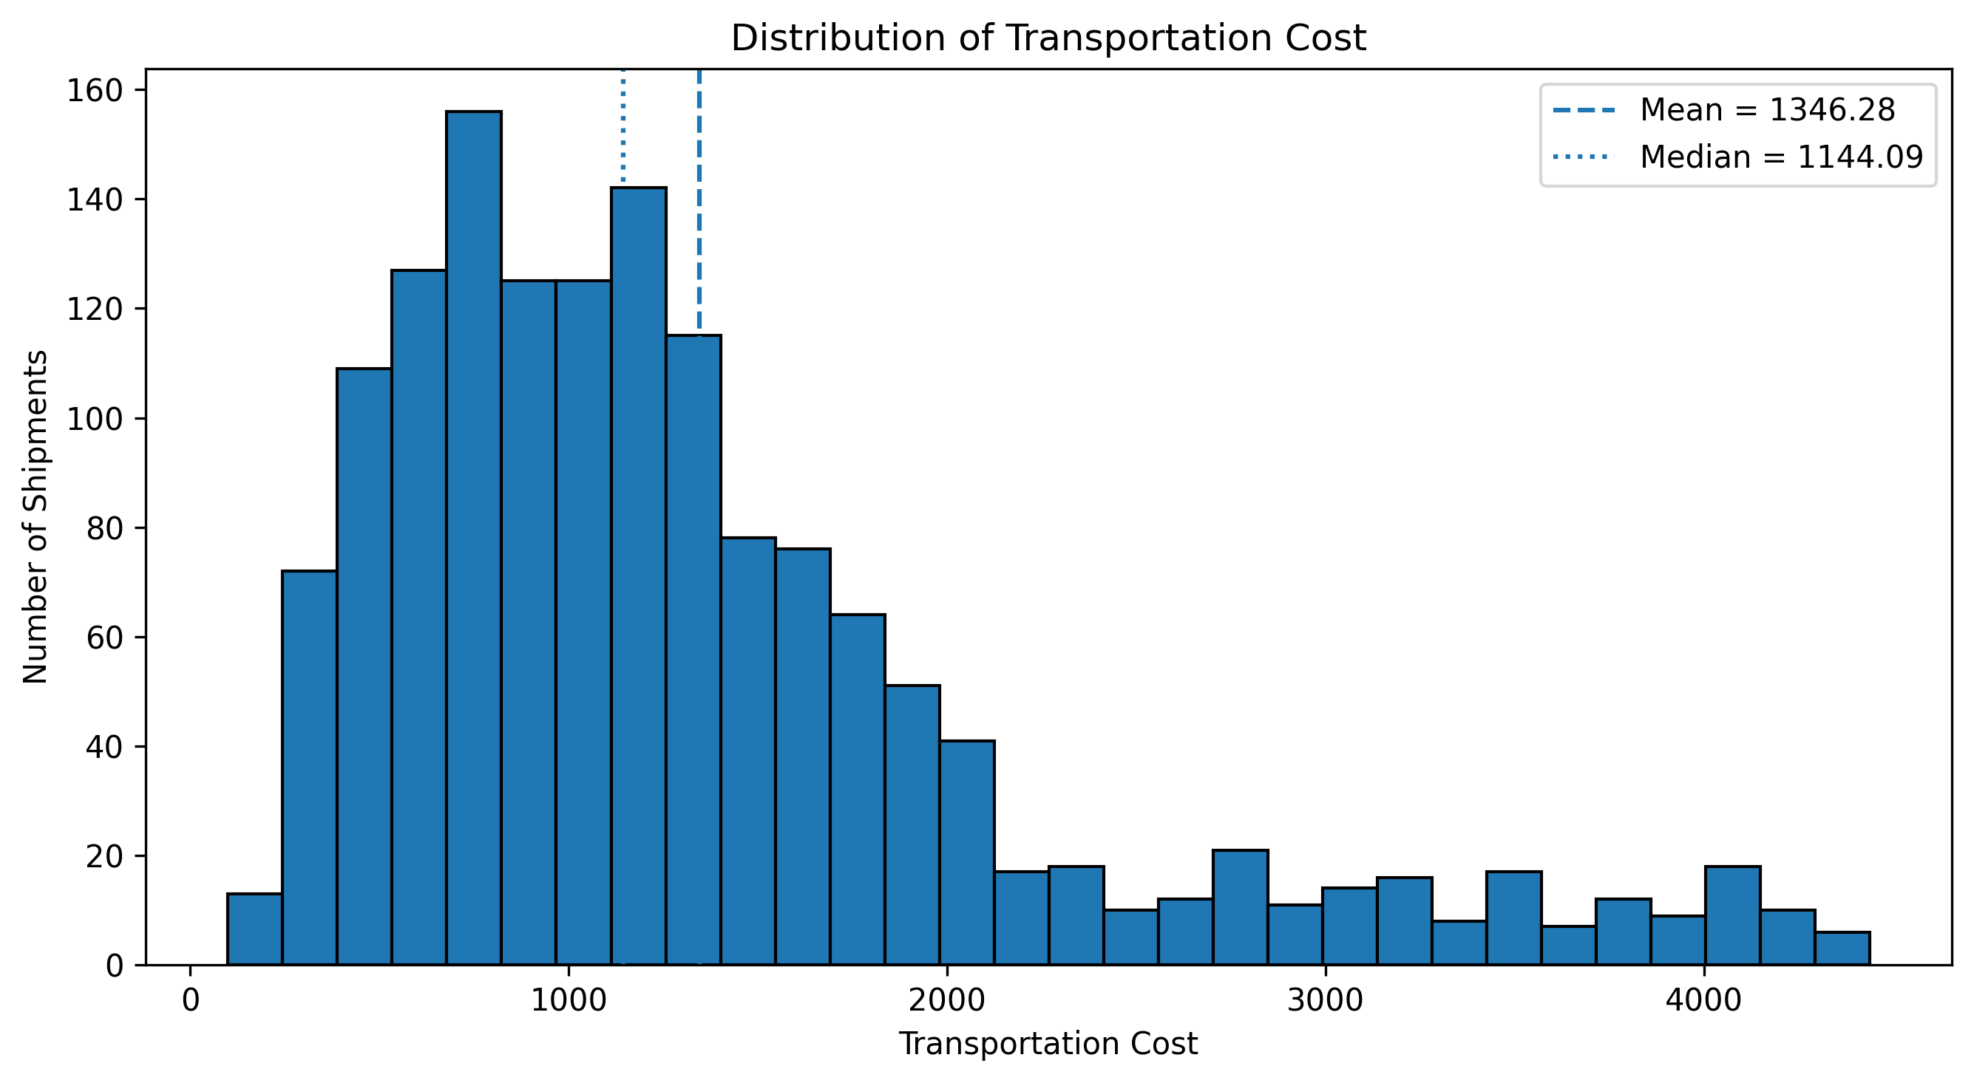
Figure 2. Transportation cost distribution with mean and median reference lines.
Transportation cost is positively skewed: the mean is 1,346.28 and the median is approximately 1,144.08. The upper tail extends beyond 4,000, indicating a smaller group of expensive shipments. The distribution alone does not explain why those shipments are costly, so relationship analysis is required.

7. Cost Driver Analysis

7.1 Transportation Cost vs Shipment Distance
A scatter plot is selected because both distance and transportation cost are continuous. It shows the direction, strength, dispersion, and possible grouping of the relationship at shipment level.
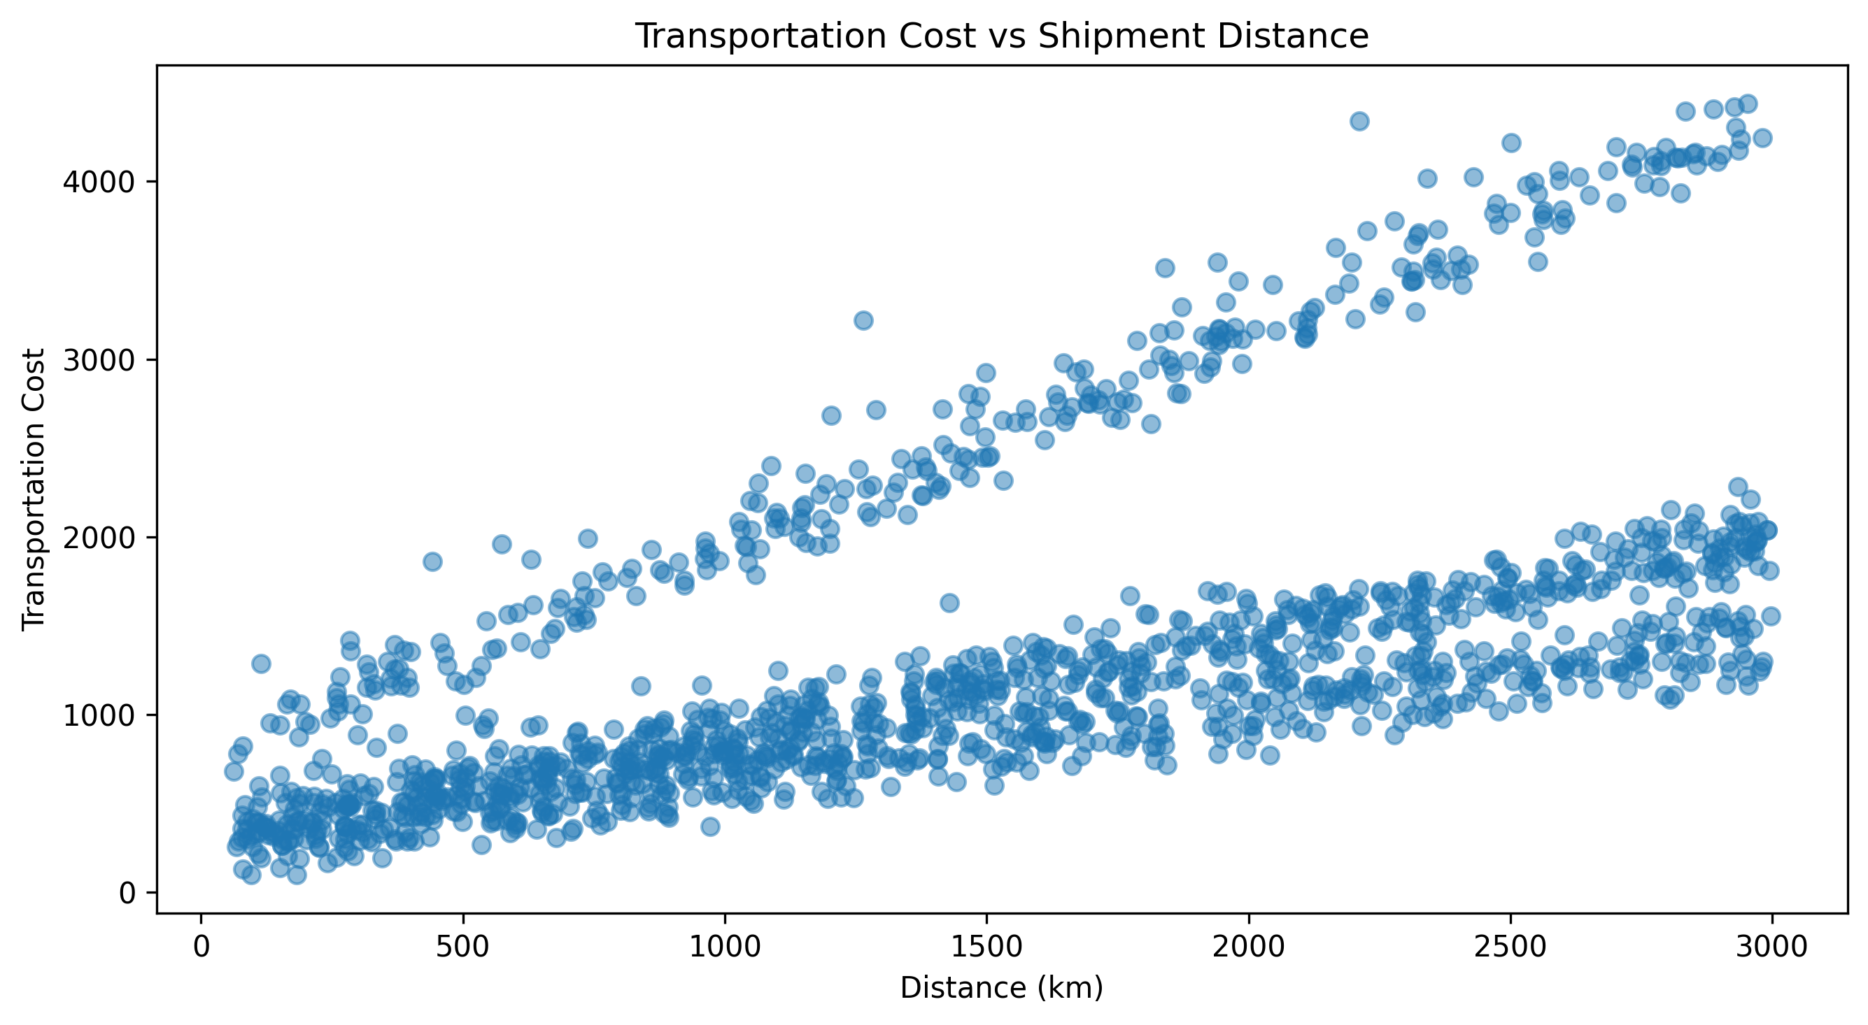
Figure 3. Transportation cost versus shipment distance.
The Pearson correlation is r = 0.600, indicating a moderate positive linear association. Longer-distance shipments tend to have higher simulated transportation costs, although substantial spread remains. Visible cost bands are consistent with differences in transport-mode cost structures. Distance should therefore be considered in cost planning, but not used alone.

7.2 Transportation Cost vs Shipment Volume
A second scatter plot evaluates whether shipment weight is strongly associated with transportation cost in the simulation.
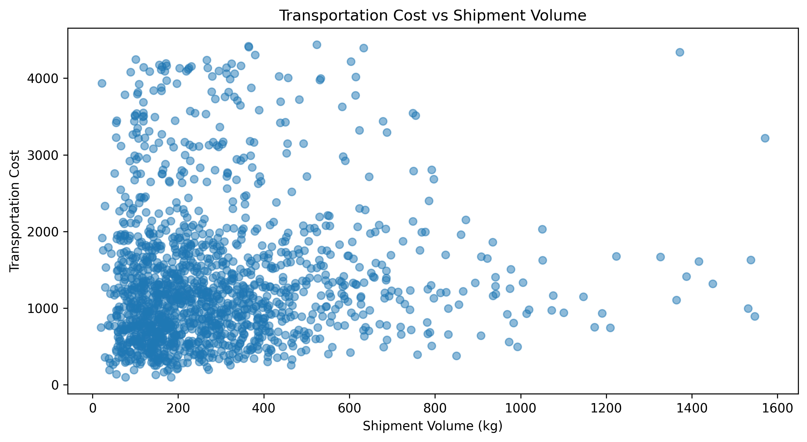
Figure 4. Transportation cost versus shipment volume.
The correlation is only r = 0.071, a very weak positive linear relationship. Shipment volume alone explains little of the observed cost variation in this simulated dataset. A practical cost model would therefore need to consider distance, mode, and other operational variables rather than relying on shipment weight as a standalone predictor.

8. Transportation Mode Performance
Grouped performance analysis compares Air, Rail, Road, and Sea across shipment count, cost, delivery duration, delay, customer rating, and on-time performance. A bar chart of average cost is used because transport mode is categorical and the purpose is direct magnitude comparison.
Mode | Shipments | Avg cost | Avg delivery (h) | Avg delay (h) | On-time | Avg rating
Air | 310 | 2613.68 | 10.07 | 4.29 | 70.32% | 4.29
Rail | 307 | 898.76 | 28.96 | 4.61 | 68.73% | 4.22
Road | 657 | 1162.53 | 33.86 | 4.52 | 67.88% | 4.22
Sea | 226 | 749.92 | 48.26 | 4.21 | 71.24% | 4.26

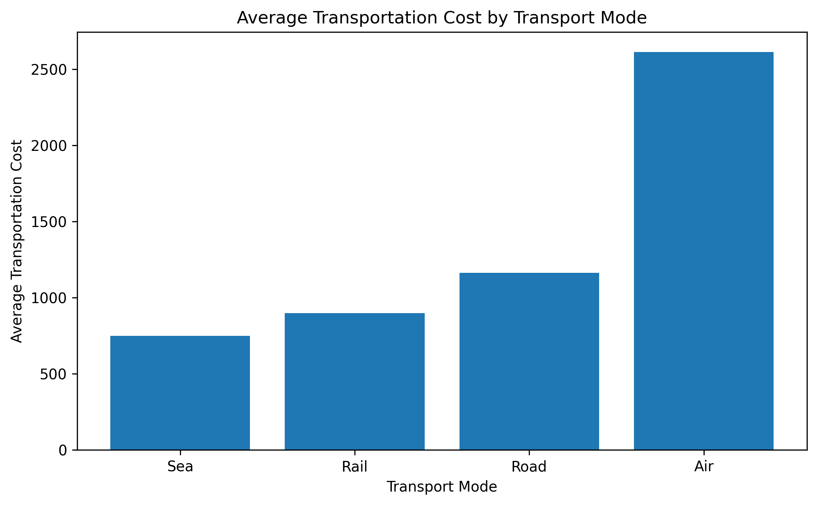
Figure 5. Average transportation cost by transport mode.
Air is the most expensive mode at an average cost of 2,613.68 but has the shortest average delivery time at 10.07 hours. Sea has the lowest average cost at 749.92 but the longest average delivery time at 48.26 hours. This demonstrates a cost-speed trade-off rather than a universally superior mode. Sea also records the highest simulated on-time rate (71.24%), which is not contradictory: on-time performance is based on delay relative to the project threshold, whereas absolute delivery duration measures total transit time.

9. Operational Bottleneck Analysis
Warehouse processing time is compared with shipment delay to test whether longer internal processing is associated with delivery disruption. A scatter plot preserves shipment-level variation, while Pearson correlation summarizes linear strength.
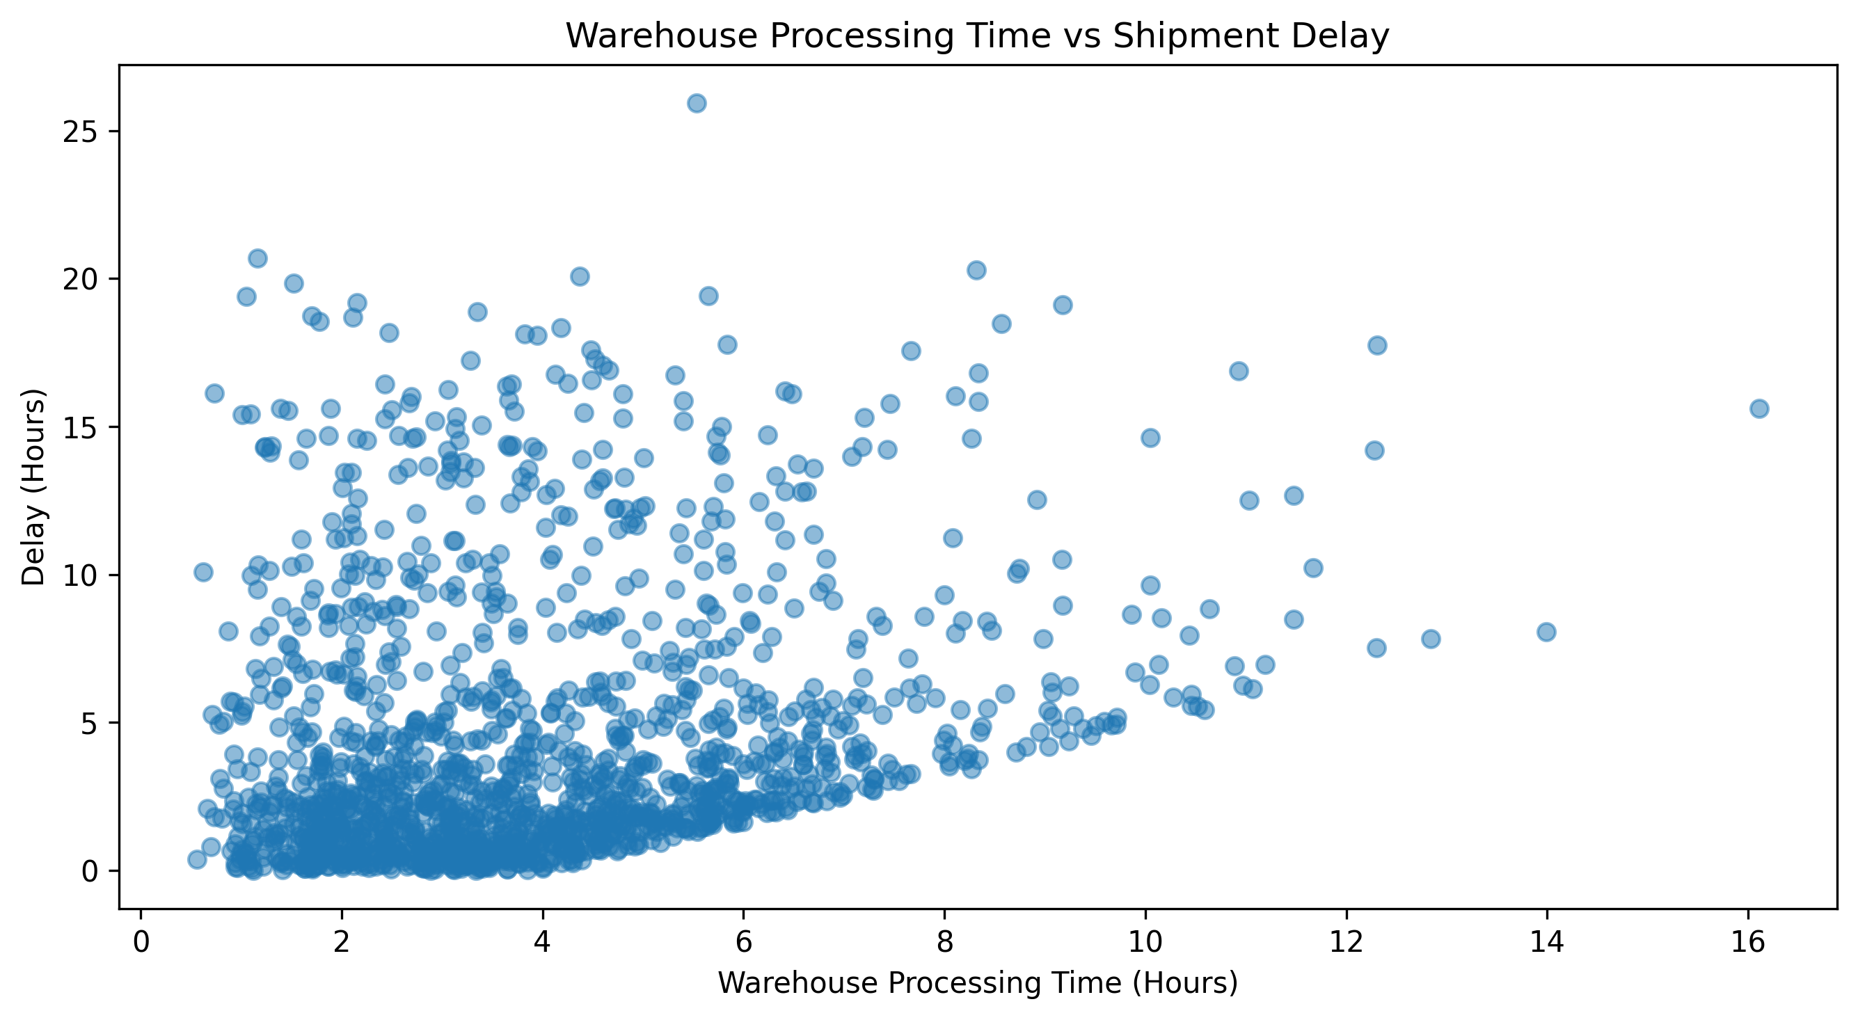
Figure 6. Warehouse processing time versus shipment delay.
The correlation is r = 0.221, a weak positive association. Longer warehouse processing may contribute to delay, but it is not the sole simulated bottleneck. Operational improvement should therefore monitor processing-time exceptions while also investigating transport disruptions and other delay sources.

10. Customer Service Impact Analysis
Delay is compared with customer rating using a scatter plot because both variables are quantitative. The chart helps show whether lower ratings cluster around larger delays.
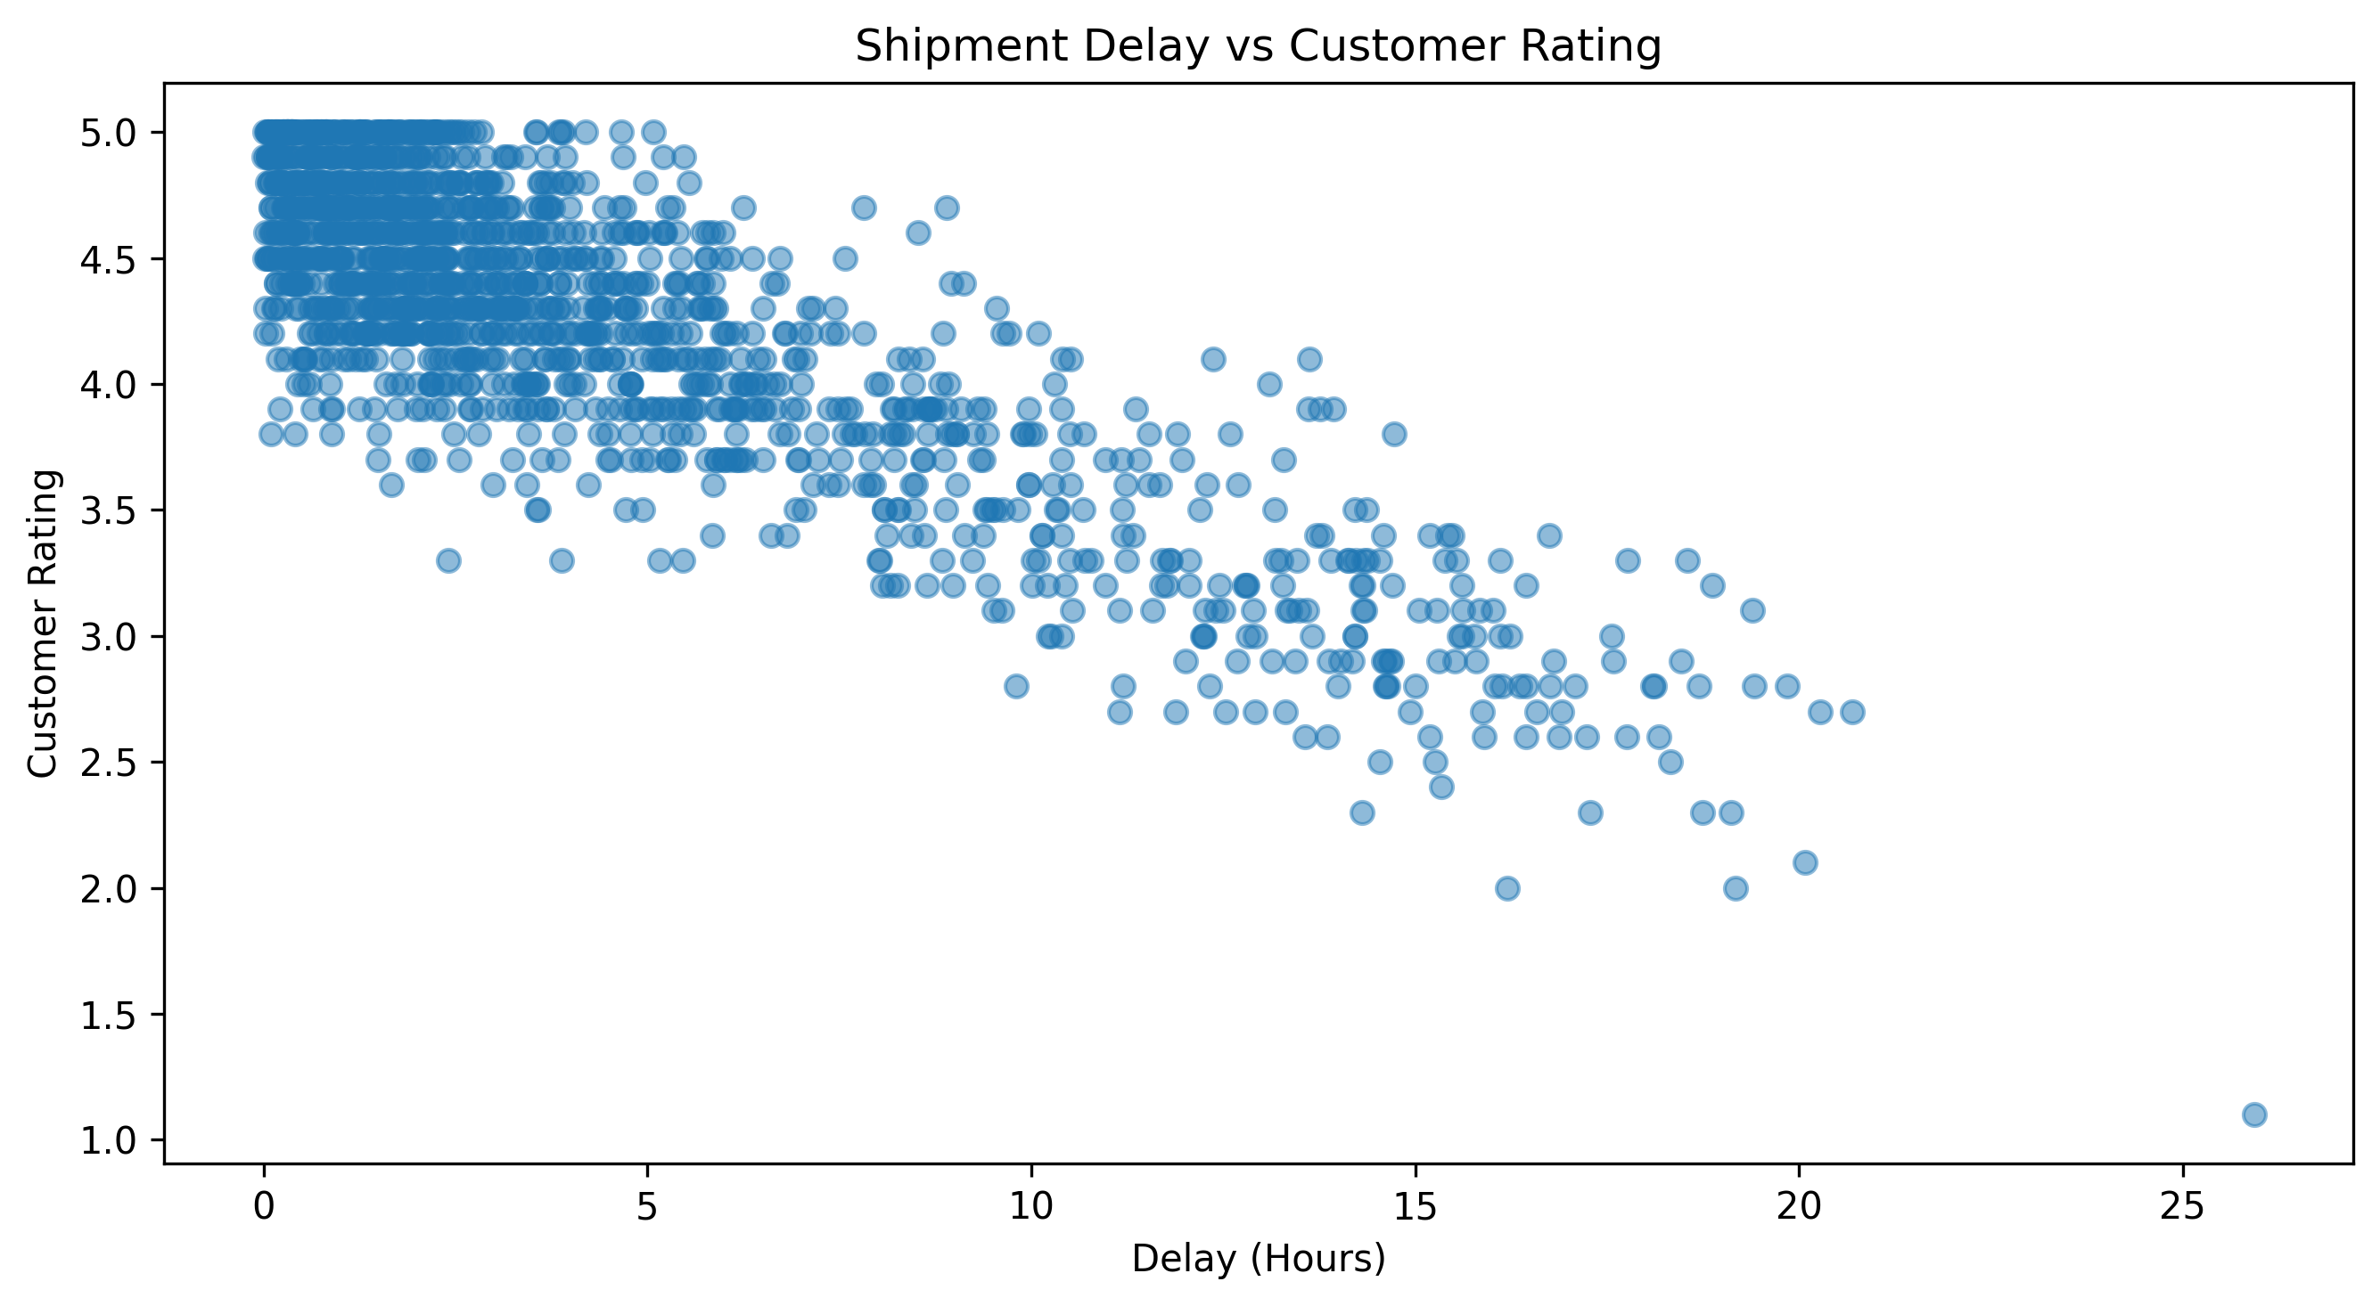
Figure 7. Shipment delay versus customer rating.
The Pearson correlation is r = -0.847, showing a strong negative association within the simulated dataset. However, this relationship was deliberately embedded in the customer-rating generation logic, where increasing delay lowers the expected rating. It must therefore not be presented as an independently discovered causal effect. In real operations, the relationship should be re-tested using actual customer feedback and independently observed delay data.

11. Correlation Analysis
A correlation matrix provides a compact overview of linear relationships among the seven main quantitative logistics variables. The heatmap is useful because it allows multiple pairwise relationships to be compared simultaneously.
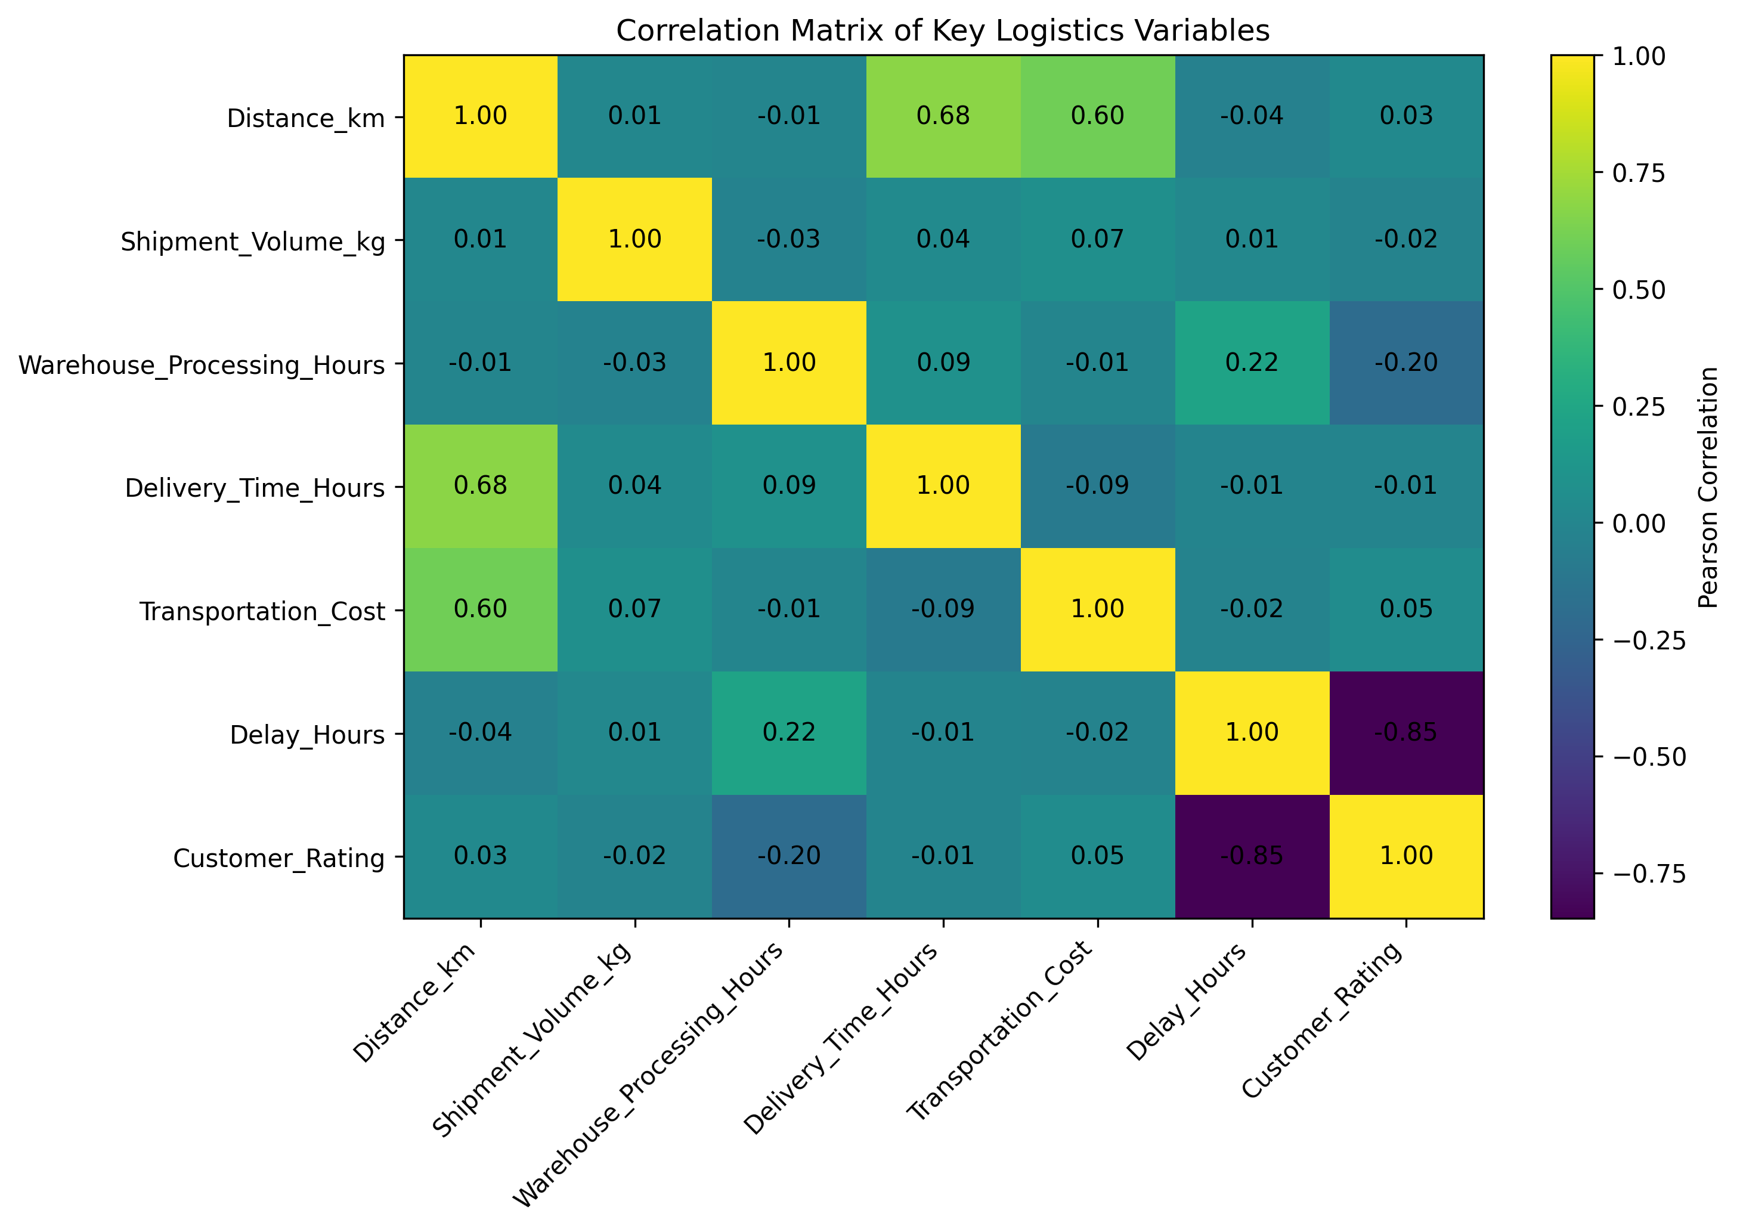
Figure 8. Pearson correlation matrix for key quantitative logistics variables.
Relationship | Pearson r | Interpretation
Distance vs delivery time | 0.679 | Strongest positive operational relationship shown
Distance vs transportation cost | 0.600 | Moderate positive association
Warehouse processing vs delay | 0.221 | Weak positive association
Shipment volume vs transportation cost | 0.071 | Very weak positive association
Delay vs customer rating | -0.847 | Strong negative association built into simulation

Correlation measures association, not causation. In particular, the strong delay-rating relationship is partly a consequence of simulation design. The matrix is most useful as a screening tool for relationships that merit deeper operational analysis.

12. Delivery Reliability Analysis
A bar chart compares the number of shipments classified as on time and delayed. This visualization is appropriate because the status variable is categorical and the operational question is the size of each group.
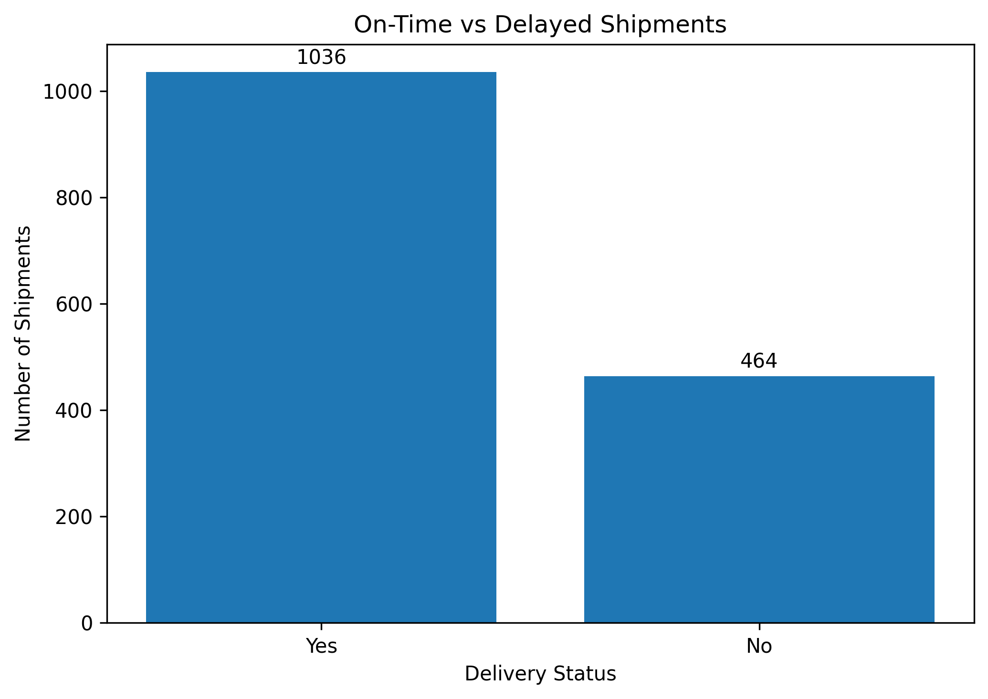
Figure 9. On-time versus delayed shipment counts.
Of 1,500 simulated shipments, 1,036 are on time and 464 are delayed under the project-specific five-hour threshold. This corresponds to 69.07% on time and 30.93% delayed. The result highlights a sizeable exception-management workload within the simulation, but it should not be compared directly with real industry service levels because the threshold is an educational project rule.

13. Monthly Logistics Trend Analysis
A line chart is selected for monthly shipment counts because month is an ordered time dimension. Connecting the monthly observations makes changes in workload across the simulated year easy to interpret.
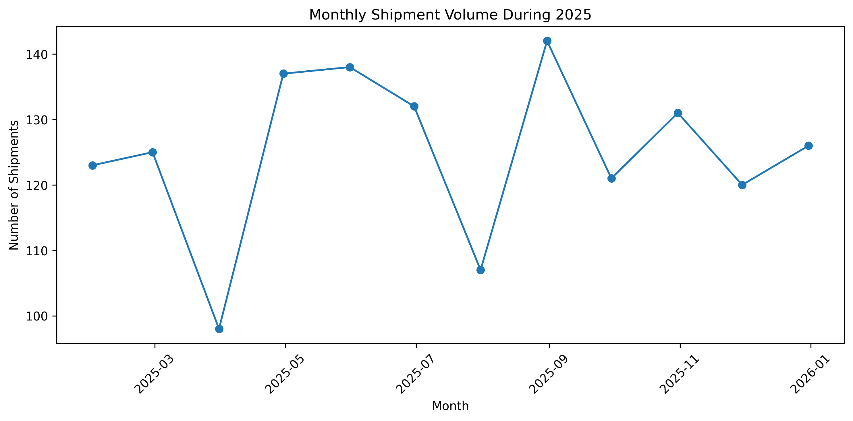
Figure 10. Monthly simulated shipment volume during 2025.
Month | Shipments
January | 123
February | 125
March | 98
April | 137
May | 138
June | 132
July | 107
August | 142
September | 121
October | 131
November | 120
December | 126

August records the highest simulated workload with 142 shipments, while March records the lowest with 98. The difference is 44 shipments. The series does not show a consistent upward or downward trend. Because shipment dates were simulated, the pattern cannot be attributed to real seasonality, holidays, weather, or demand cycles.

14. Regional Performance Analysis
Regional grouping provides an additional operational comparison across shipment count, delivery time, transportation cost, delay, customer rating, and on-time rate. Because regions were assigned in a hypothetical simulation, differences are treated as analytical signals for further segmentation rather than geographic causal effects.
Region | Shipments | Avg delivery (h) | Avg cost | Avg delay (h) | Avg rating | On-time
East | 384 | 30.48 | 1353.61 | 4.58 | 4.22 | 65.62%
North | 409 | 29.07 | 1333.89 | 4.32 | 4.25 | 72.37%
South | 338 | 29.61 | 1326.75 | 4.40 | 4.24 | 69.23%
West | 369 | 31.33 | 1370.29 | 4.48 | 4.25 | 68.83%

North handles the largest simulated shipment volume (409) and records the highest on-time rate (72.37%). East records the lowest on-time rate (65.62%) and the highest average delay (4.58 hours), while West has the highest average delivery time (31.33 hours) and average transportation cost (1,370.29). A practical next step would be to compare mode mix, distance, warehouse processing, and delay sources within each region before proposing corrective action.

15. Consolidated Analytical Findings
Analysis area | Concrete evidence | Operational interpretation
Delivery reliability | 69.07% on time; 30.93% delayed | Nearly one-third exceed the project-specific delay threshold.
Delivery-time distribution | Mean 30.11 h; median 26.16 h | Right-skewed distribution with a long-duration tail.
Cost distribution | Mean 1,346.28; median 1,144.08 | High-cost tail raises the average.
Distance-cost relationship | r = 0.600 | Distance is a meaningful cost-related factor, but not a complete explanation.
Distance-delivery relationship | r = 0.679 | Longer simulated distances are associated with longer delivery times.
Volume-cost relationship | r = 0.071 | Shipment weight alone has little linear association with cost.
Warehouse-delay relationship | r = 0.221 | Warehouse processing is only a weak delay-related factor.
Delay-rating relationship | r = -0.847 | Strong negative relationship, intentionally designed into the simulation.
Mode trade-off | Air 10.07 h / 2,613.68; Sea 48.26 h / 749.92 | Clear simulated speed-cost trade-off.
Monthly workload | August 142; March 98 | Workload varies, but no real seasonality can be inferred.
Regional reliability | North 72.37%; East 65.62% | Regional KPI differences warrant composition/process review.

Taken together, the evidence shows why logistics performance should be evaluated across cost, speed, reliability, internal processing, workload, and customer outcomes rather than through a single KPI.

16. Actionable Logistics Recommendations
1. Strengthen delay and exception management
With 30.93% of shipments outside the project-defined on-time threshold, delayed shipments should be segmented by mode, distance, warehouse processing, and operational disruption type to distinguish recurring bottlenecks from isolated exceptions.
2. Monitor warehouse processing without treating it as the sole bottleneck
The warehouse-processing-to-delay correlation is only r = 0.221. Processing-time thresholds and alerts are useful, but improvement efforts should also investigate other operational delay sources.
3. Use transport mode according to cost-service requirements
Air is fastest but most expensive, while Sea is cheapest but slowest. Mode selection should combine urgency, service requirements, cost constraints, and schedule reliability rather than automatically choosing one mode.
4. Include distance in transportation cost planning
Distance has a moderate positive relationship with cost (r = 0.600). It should be included in budgeting, route evaluation, and cost forecasting alongside transport mode and other shipment characteristics.
5. Do not use shipment weight alone for cost decisions
Shipment volume has only a very weak relationship with cost (r = 0.071). Cost estimation should use multiple operational variables rather than weight alone.
6. Prioritize management of severe delays
The simulated delay-rating relationship is strongly negative, but intentionally designed. In real operations, validate this relationship first, then use delay-risk alerts and proactive customer communication where supported.
7. Use monthly workload monitoring for capacity planning
Monthly volume ranges from 98 to 142 shipments. Regular workload monitoring can inform staffing, vehicle planning, scheduling, and resource allocation, without treating the simulated monthly pattern as real seasonality.
8. Investigate regional KPI differences before corrective action
North and East differ by 6.75 percentage points in on-time rate. Compare mode mix, distance, warehouse processing, and delay sources before attributing performance differences to geography.

17. Feasibility and Limitations

17.1 Feasibility
The analytical workflow is technically feasible for a real logistics environment. Descriptive statistics, KPI calculation, grouped performance analysis, Pearson correlation, histograms, scatter plots, bar charts, and time-series visualization can all be applied to operational shipment data using Python and pandas. The same framework could support transportation-cost monitoring, delivery-performance tracking, warehouse bottleneck investigation, regional comparison, capacity planning, and customer-service analysis when validated real-world data are available.

17.2 Key Limitations
- Simulated data: all 1,500 records were generated for educational analysis and do not represent an actual logistics company.
- Designed relationships: some relationships were intentionally incorporated during data generation, especially the negative delay-to-customer-rating relationship.
- Simplified on-time definition: delay of 5 hours or less is treated as on time for this project; real analysis should use contractual promised-delivery times or service-level agreements.
- Limited operational variables: the dataset excludes fuel prices, traffic, weather, carrier performance, vehicle capacity, route congestion, customs processing, facility capacity, and detailed delay-reason codes.
- Correlation does not establish causation: Pearson correlation measures linear association only.
- No real seasonal evidence: monthly volume changes are simulated and cannot support claims about real demand cycles or seasonality.

17.3 Appropriate Use of Results
The results are appropriate for demonstrating logistics EDA, visualization selection, KPI interpretation, and evidence-based decision-support methodology. They are not sufficient for direct operational implementation, real demand forecasting, industry benchmarking, or causal claims. Real-world deployment would require validated operational data, business rules, service-level definitions, domain expertise, and additional explanatory variables.

18. Python Tools and Reproducibility
The analysis was implemented in Google Colab using Python. pandas was used for tabular data construction, grouping, summary statistics, KPI calculations, and correlations; NumPy supported simulation; and Matplotlib was used to generate the submitted visualizations. The notebook preserves the analytical sequence, code, outputs, and written interpretations.

Representative analysis logic
Descriptive statistics
descriptive_stats = df[quantitative_columns].describe().T\ndescriptive_stats["median"] = df[quantitative_columns].median()
On-time KPI
on_time_rate = (df["On_Time_Delivery"] == "Yes").mean() * 100
Correlation
distance_cost_corr = df["Distance_km"].corr(df["Transportation_Cost"])
Grouped mode performance
mode_summary = df.groupby("Transport_Mode").agg(...)
Monthly workload
monthly_shipments = df.groupby(df["Shipment_Date"].dt.month)["Shipment_ID"].count()
The complete reproducible code is retained in the submitted notebook: Yuva_Intern_Task_3_Advanced_Logistics_Analysis.ipynb.

19. How the Visualizations Support Logistics Interpretation
Visualization | Used for | Logistics interpretation value
Histogram | Delivery time; transportation cost | Shows frequency, spread, skewness, and long tails in continuous performance measures.
Scatter plot | Cost-distance; cost-volume; processing-delay; delay-rating | Shows shipment-level relationships, dispersion, clusters, and possible outliers between two numeric variables.
Bar chart | Transport-mode cost; on-time vs delayed | Supports direct categorical comparison of magnitude and operational status.
Correlation heatmap | Seven quantitative variables | Summarizes many pairwise linear relationships in one compact analytical view.
Line chart | Monthly shipment volume | Preserves time order and shows month-to-month workload variation.

Visualization choice was based on variable type and analytical purpose rather than decoration. Each chart is paired with quantitative evidence and a narrative interpretation so that the visual output contributes directly to operational reasoning.

20. Reflection and Conclusion
This project demonstrates how exploratory data analysis and visualization can transform structured logistics data into interpretable operational evidence. Starting with 1,500 simulated shipments and 13 variables, the workflow examined delivery performance, transportation cost, shipment volume, warehouse processing, delays, transport modes, regional performance, monthly workload, and customer ratings.
The analysis also demonstrates why a single KPI is insufficient. Transport mode involves a cost-service trade-off; distance is associated with both delivery time and cost; warehouse processing has only a weak association with delay; and shipment volume alone provides little explanation for cost variation. Delivery reliability provides a different operational perspective from absolute delivery duration.
Visualizations make these patterns easier to communicate: histograms expose skewed distributions, scatter plots show relationships and dispersion, bar charts compare categories, the correlation matrix summarizes multiple associations, and the monthly line chart displays workload variation over time.
The most important methodological lesson is that statistical relationships must be interpreted with business context and clear limitations. Correlation does not establish causation, and simulated findings cannot be treated as real organizational benchmarks. Nevertheless, the project provides a reproducible framework that can be adapted to validated real logistics data for evidence-based decision support.

Appendix A. Submitted Project Assets
Asset | Filename | Purpose
Hypothetical dataset | Task_3_Hypothetical_Logistics_Dataset.csv | 1,500 rows × 13 columns
Analysis notebook | Yuva_Intern_Task_3_Advanced_Logistics_Analysis.ipynb | Python code, outputs, interpretations
Visualization package | Task_3_Charts.zip | 10 PNG visualization outputs
Project report | Task_3_Advanced_Logistics_Analysis_Report.docx | Methodology, findings, visuals, recommendations

Appendix B. Analytical Integrity Notes
- All numerical findings in this report are derived from the supplied simulated dataset and notebook workflow.
- The customer-rating relationship with delay is explicitly disclosed as simulation-designed.
- The five-hour on-time threshold is explicitly identified as project-specific.
- No causal conclusions are drawn from Pearson correlation.
- Monthly and regional differences are not presented as real seasonality or geographic effects.

